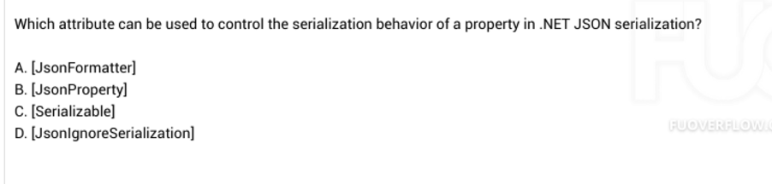

1. Serialization behaviour -> JsonFormatter

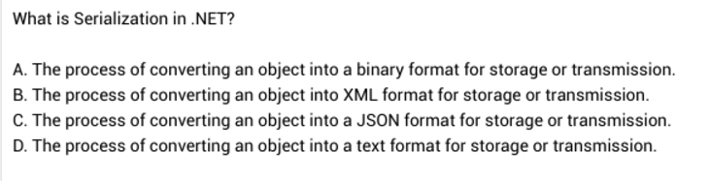

A



Flexible grid -> Grid

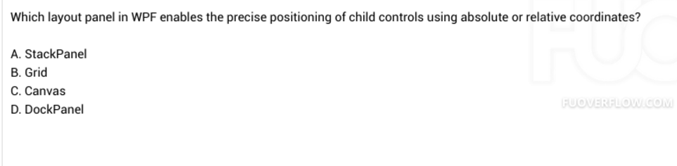

Absolute - relative : Canvas

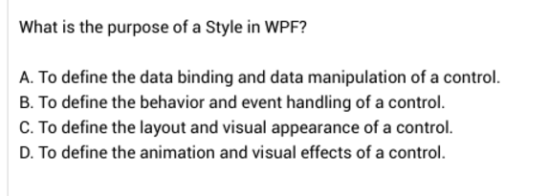

C



1. To ensure only one instance of a class is created

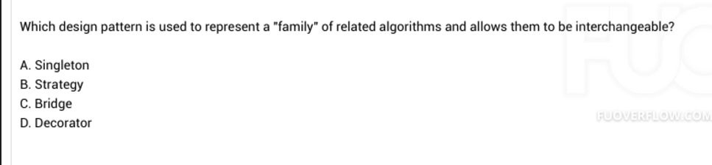

Family -> Strategy



1. Factory Method: By allowing dynamic determination…

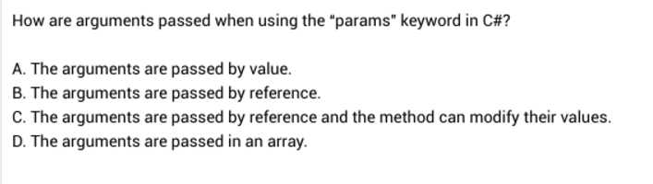

The arguments are passed in an array

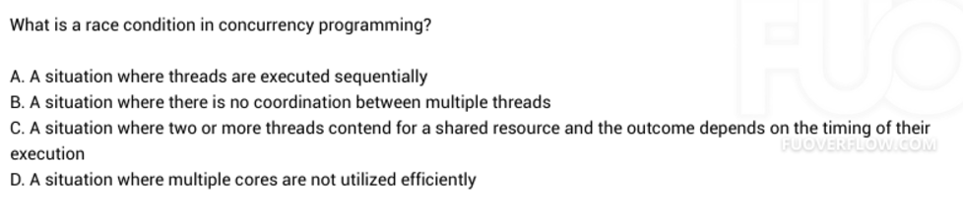

A situation where two or more threads contend…

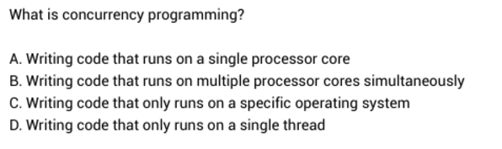

1. Writing code that rún on multiple processor

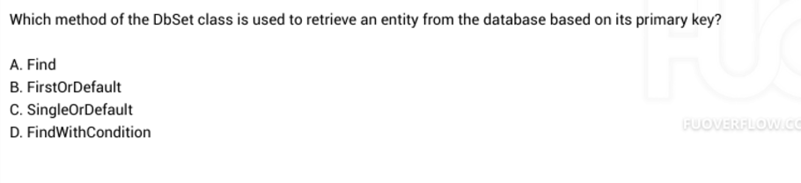

Primary key -> find

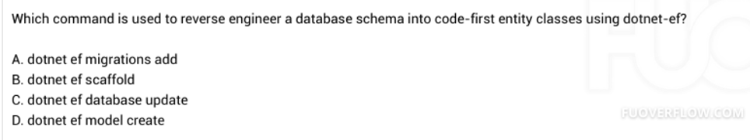

Reverse engineer -> dot net ef scaffold

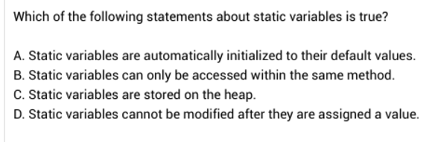

Static variables are automatically initialised to their default values

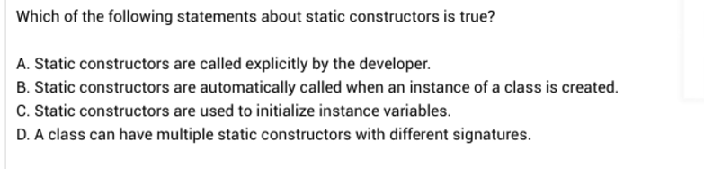

B

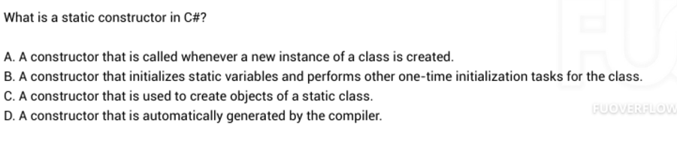

B

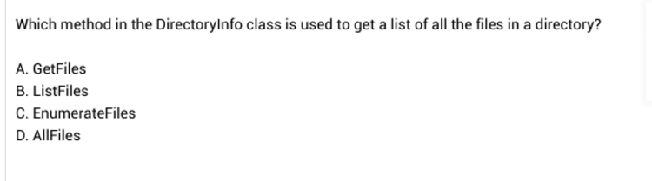

A

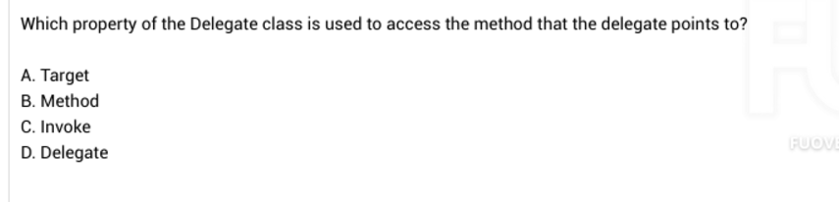

B

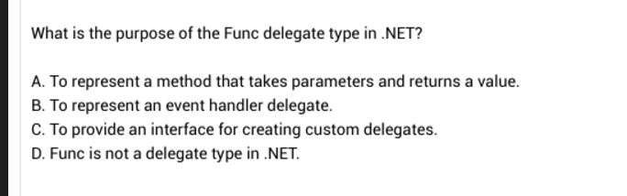

A.

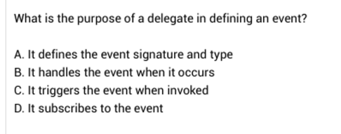

A

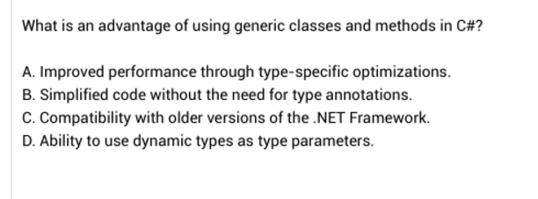

Improved performance through type-specific optimizations

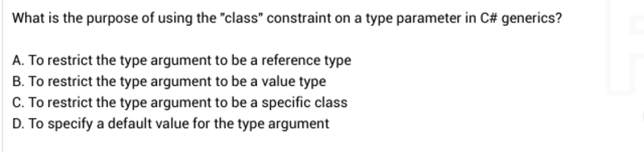

1. To restrict the type argument to ben a reference type

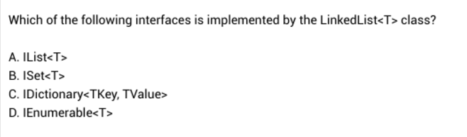

D.

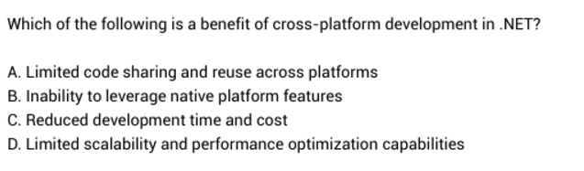

C

—-----

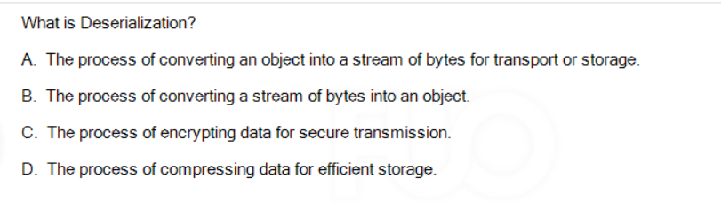

1. The process of converting a stream of bytes into an object

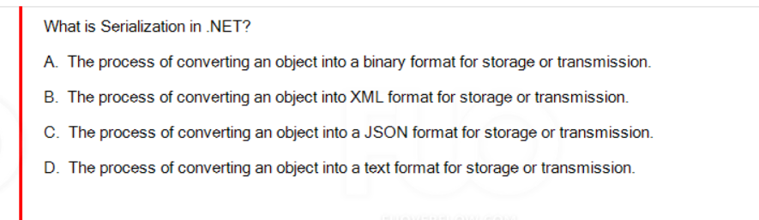

1. Converting an object into a binary

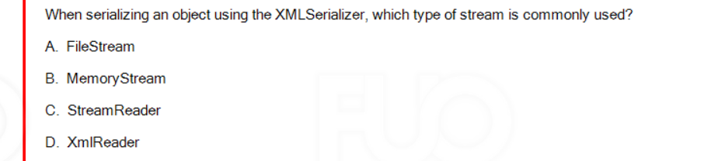

1. FileStream

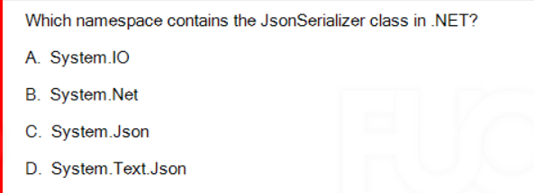

System.Text.Json

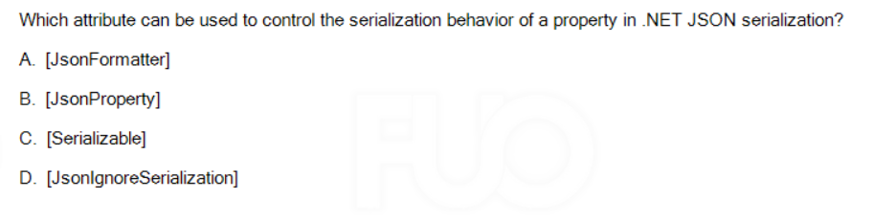

1. [JsonProperty]

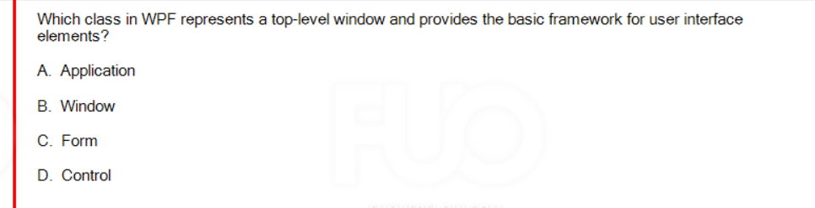

Interface elements -> Window

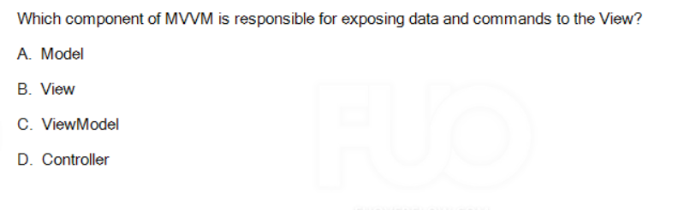

C ViewModel

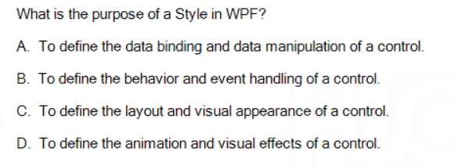

1. To define the layout and visual appearance of a control

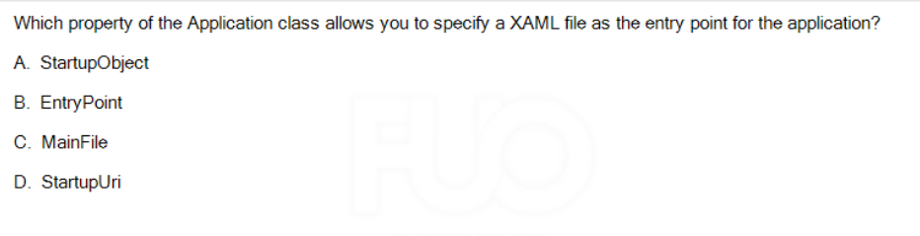

1. StartupUri

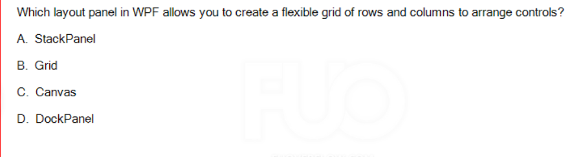

Flexible grid -> Grid

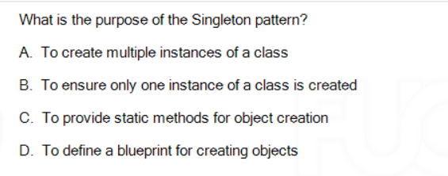

1. To ensure only one instance of a class created

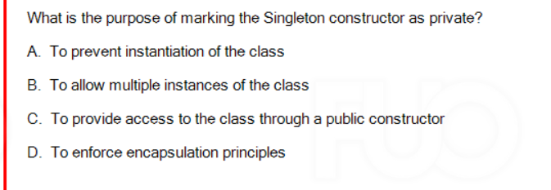

To prevent instantiation of the class

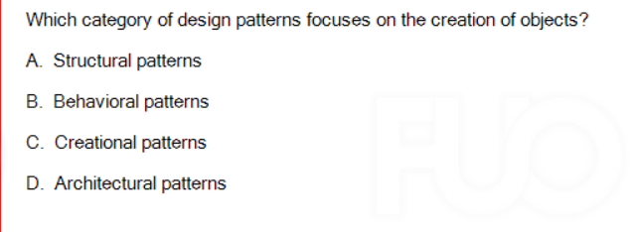

1. Creational patterns

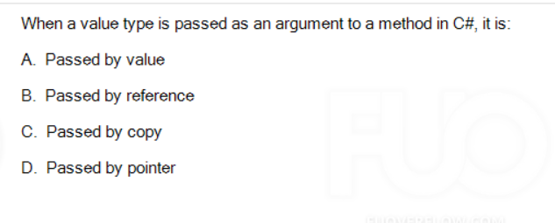

1. Passed by value

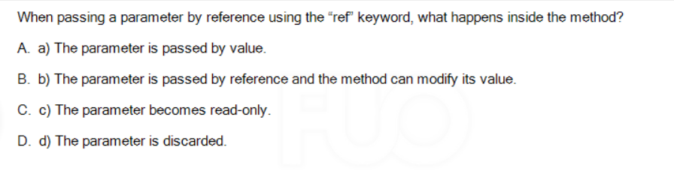

B

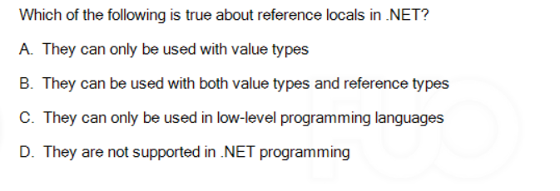

1. They can be used with both value types and reference types

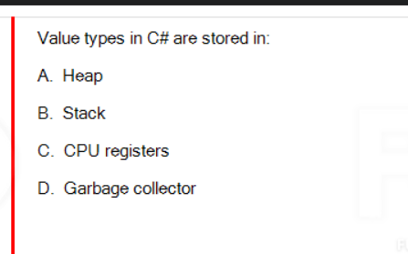

Stack

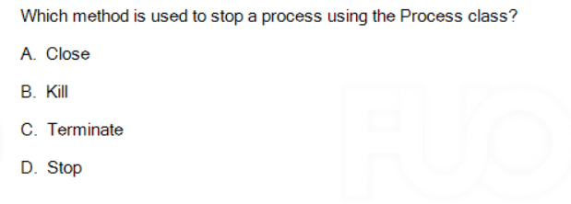

Kill

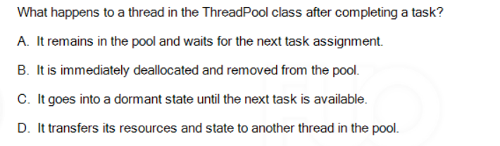

It remains

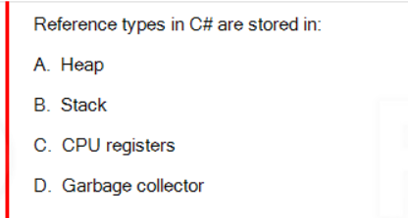

A

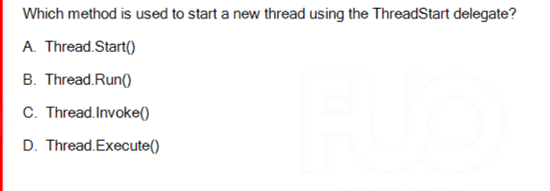

A

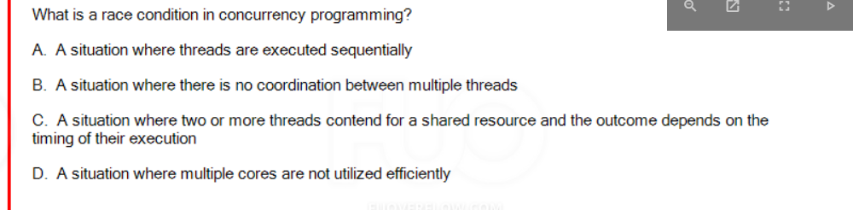

C . Two or more threads

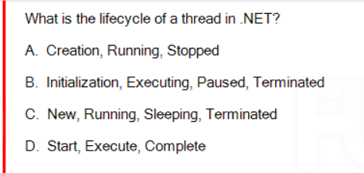

C. New Running Sleeping Terminated

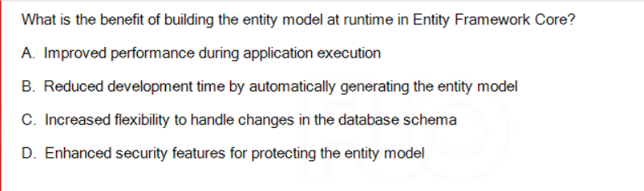

C

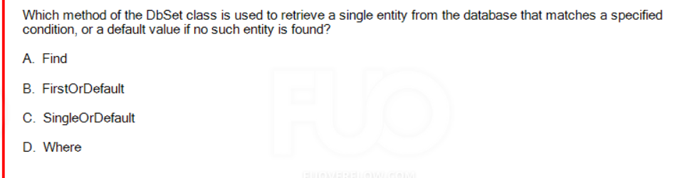

B

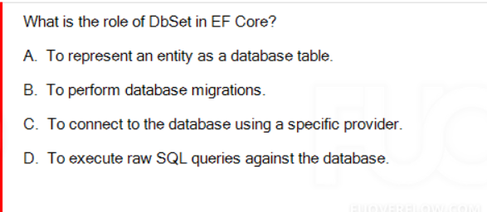

1. To represent an entity as a database table

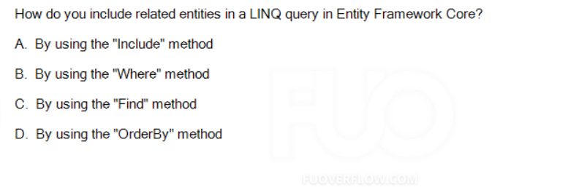

A

Include related -> A

Project Specific -> C

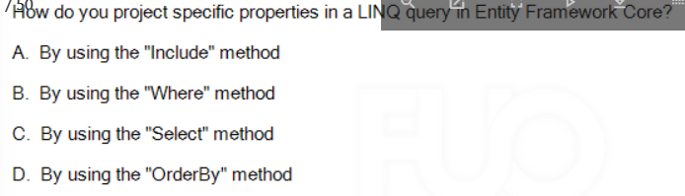

C

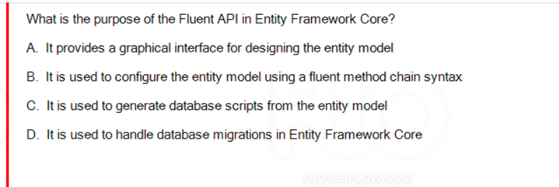

1. Nếu ae k dùng annotation trong code first thì có thể dùng fluent api

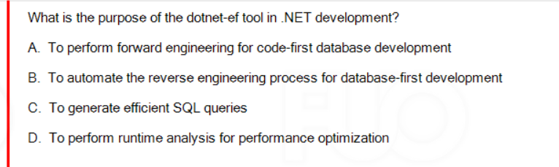

B To automate the reverse engineering process

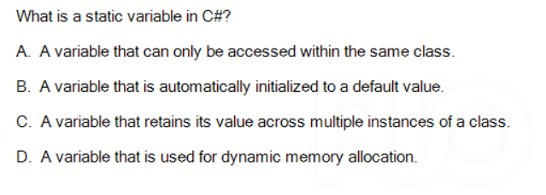

C

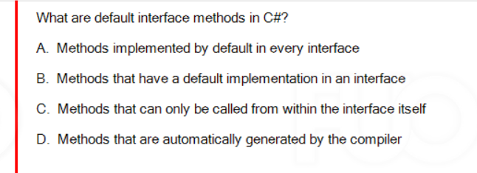

B. Method that have a default…

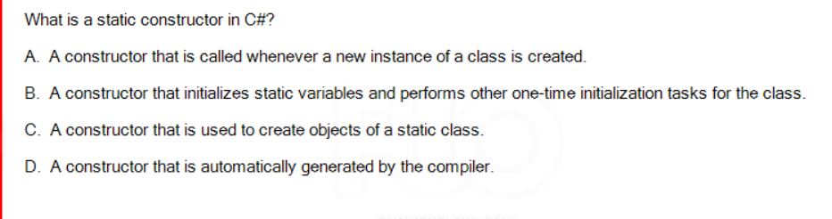B. A constructor that intializes static variables

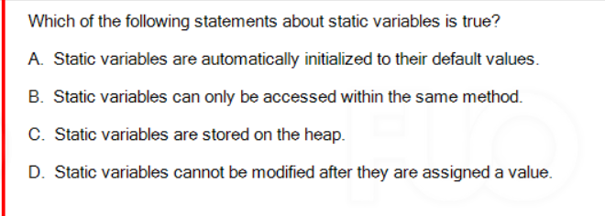

A

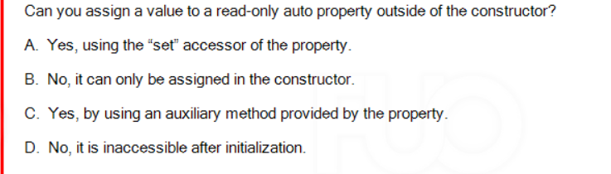

B. No , it can only be assigned in the constructor

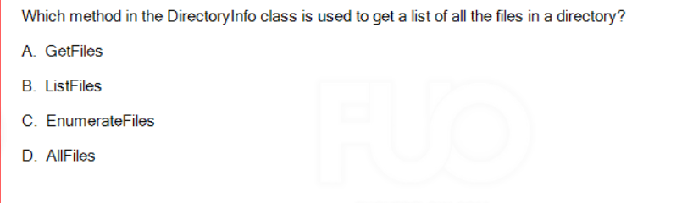A -> Get a list là GetFiles

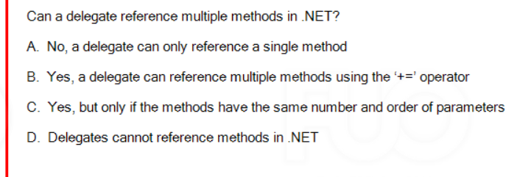

B. Yes, a delegate can reference multiple methods…

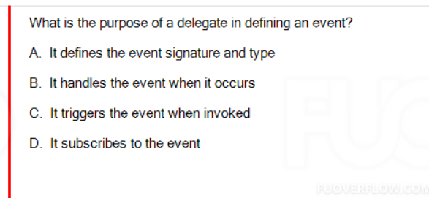

1. It defines the event signature

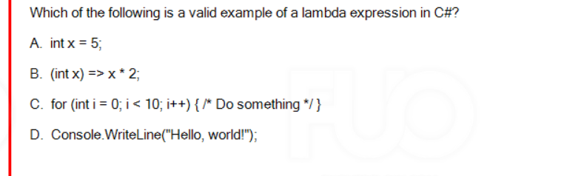

B Lambda nè

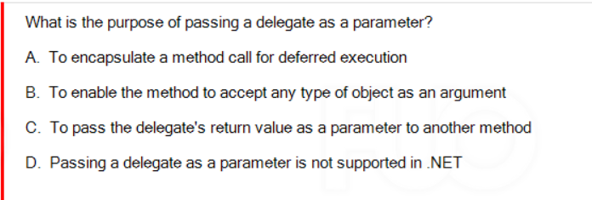

1. To encapsulate a method call for deferred execution

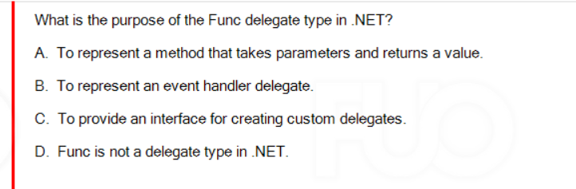

1. To represent a method that takes parameters and returns a value

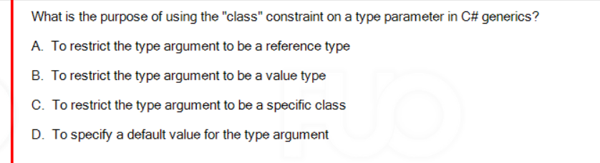

1. To restrict the type argument to be a reference type

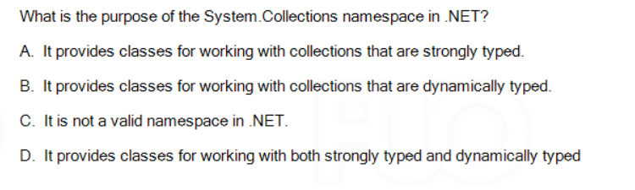

D

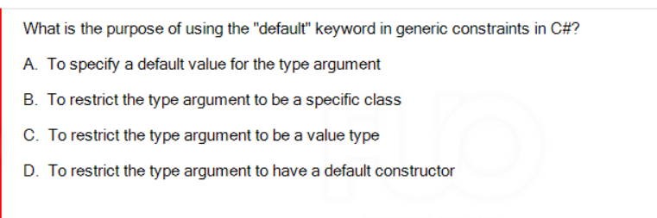

D, To restrict the type argument to have a default constructor

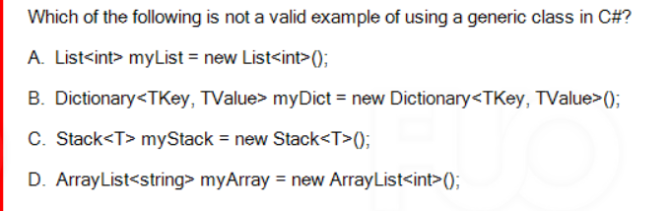D

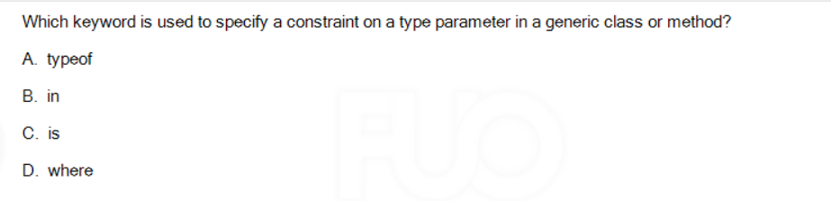

D. Where -> constraint on a type parameter

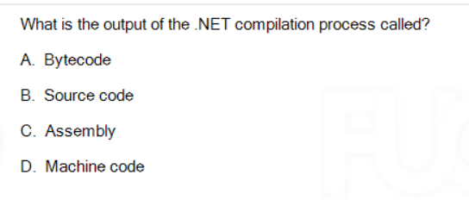

C

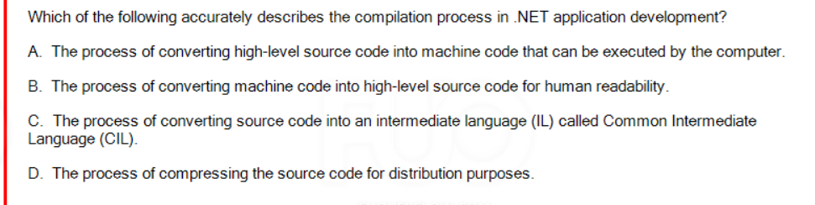

IL , CIL -> C

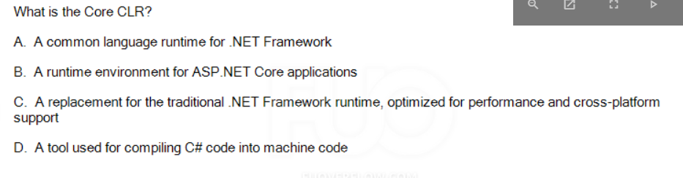c

C

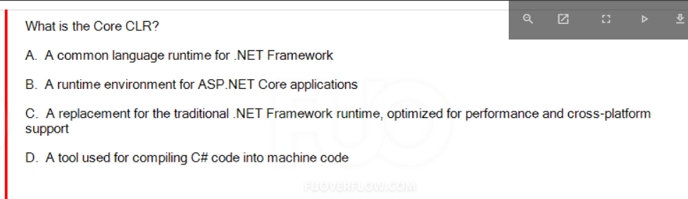

C

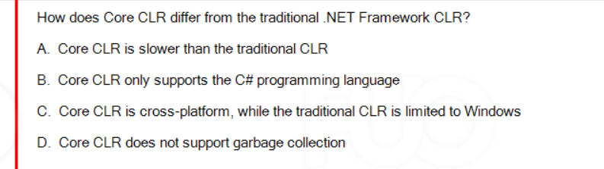

Cross-platform , limited to windows -> C

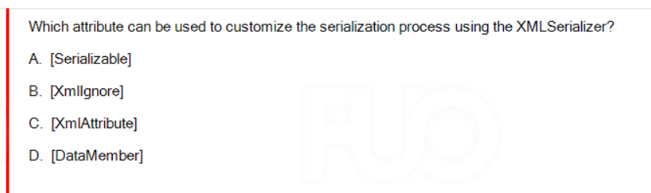

XmlAttribute

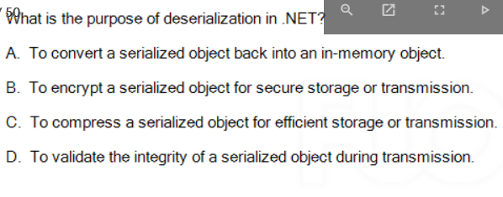

A

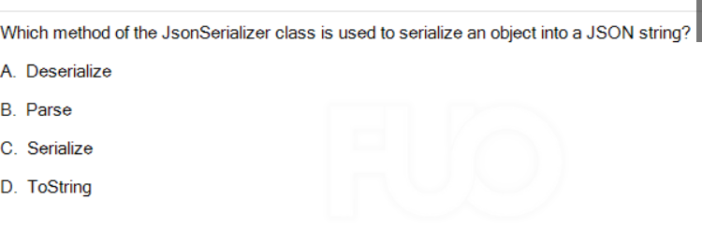

C

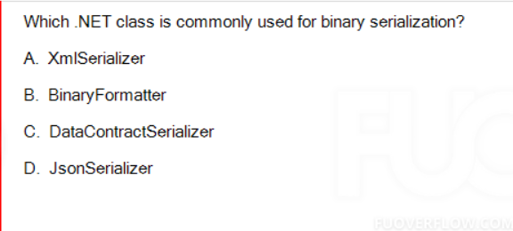

1. Binary serialization -> Binary formatter

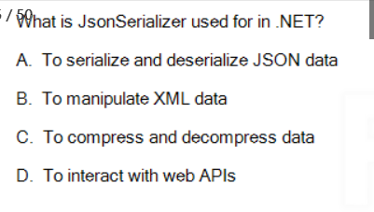

1. TO serialize and deserialize JSON data

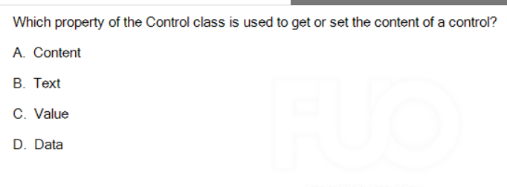

Content



Layout Panel -> StackPanel

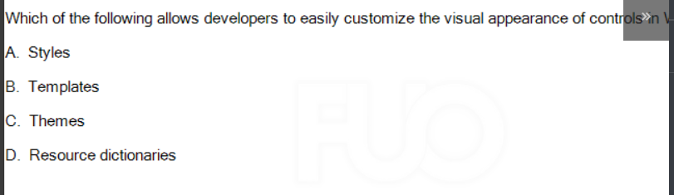

1. Templates

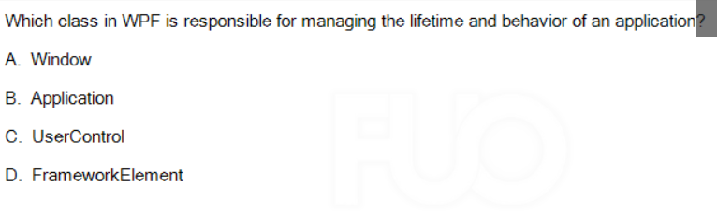

B. Responsible for managing the lifetimes and behavior of an apllicaqtion -> Application

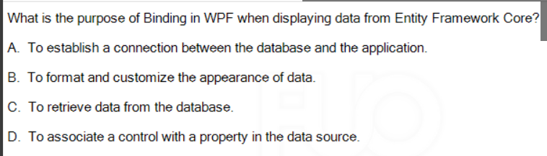

To associate a control with a property in the data source

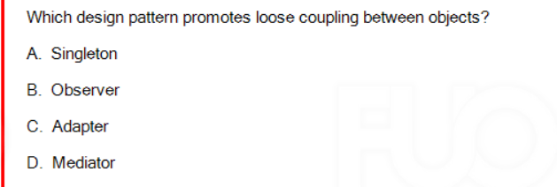

Mediator -> Loose coupling

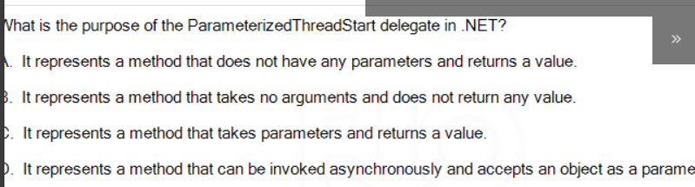

ParametedrizedThreadStart -> D. It represents a method that can be invouked

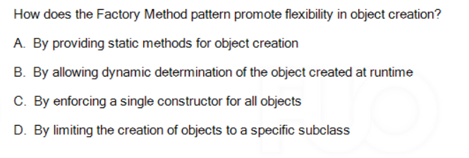

B. By allowing dynamic determination of the object created at runtime

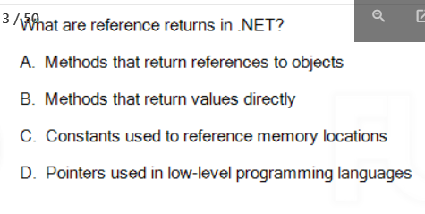

A

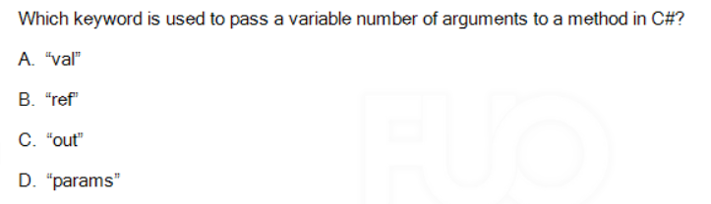

D. “param”

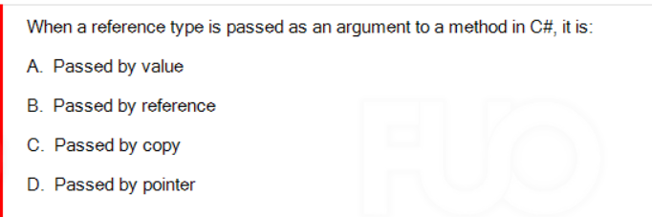

Passed by value

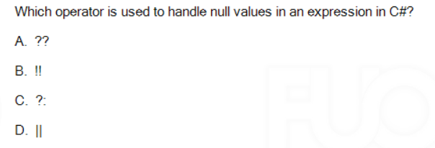

A

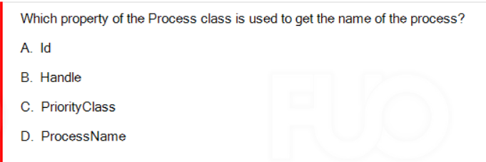

D, ProcessName

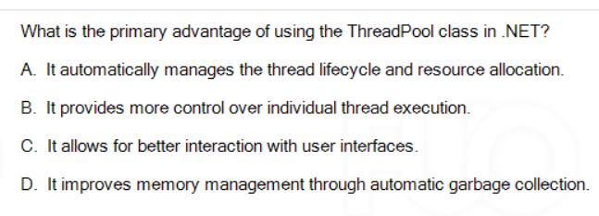

1. It automatically manage the threads lifecycle

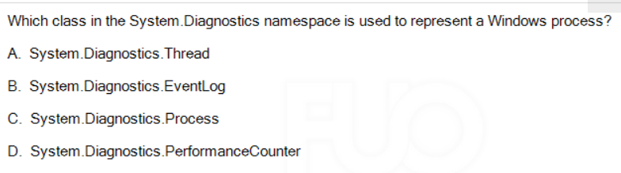

C

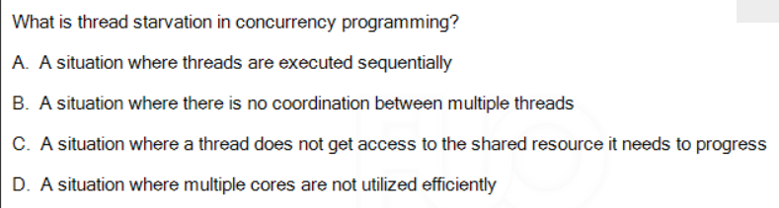

A situation where a thread does not get access to the shared resource it needs to progress

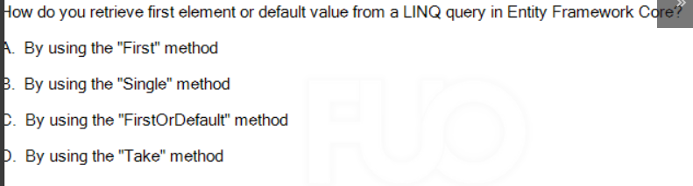

C

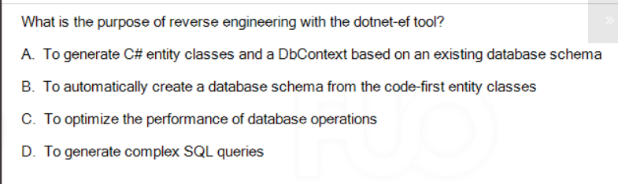

A

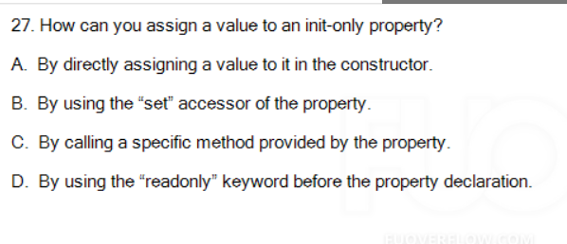

A

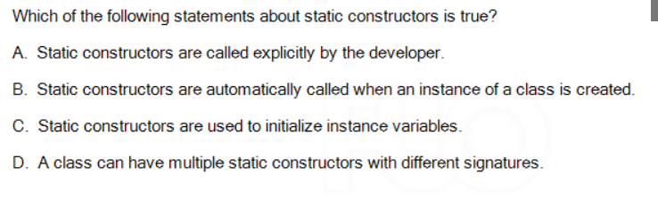

B

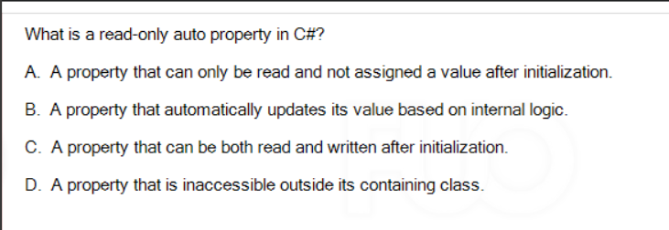

A

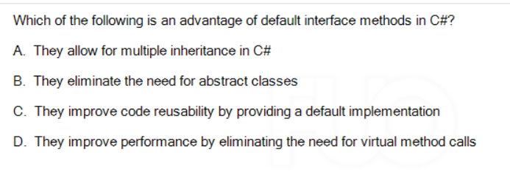

C. They improve code reusability

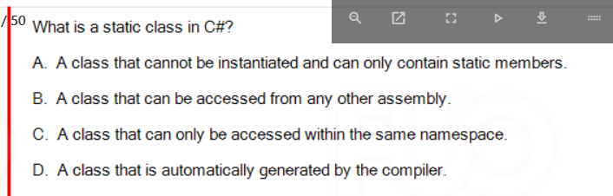

C. A class that can only be accessed within the same namespace

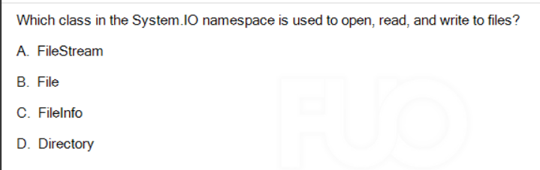

A

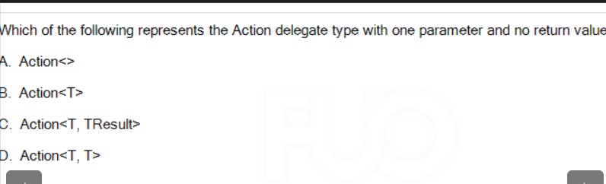

B

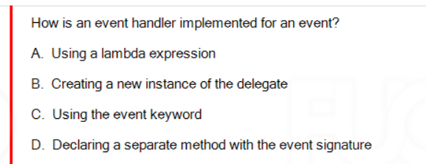

D. Declaring a separate method with the event signature

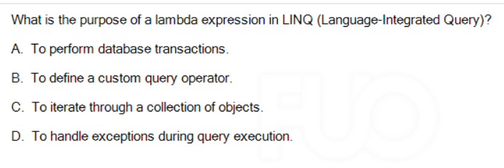

B, To define a custom query operator

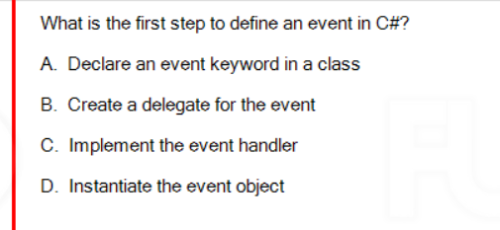

B

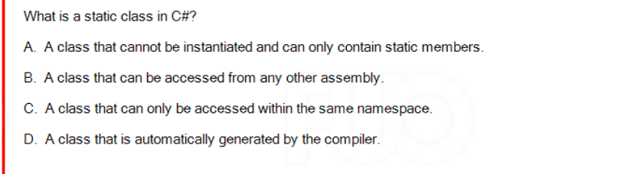

A class that cannot be instantiated and can only contain static members

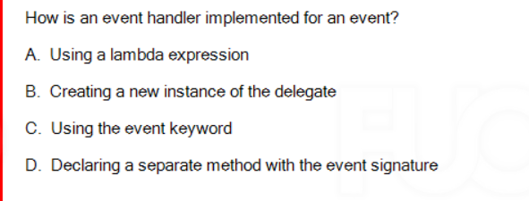

D Declaring a separate method with the event signature

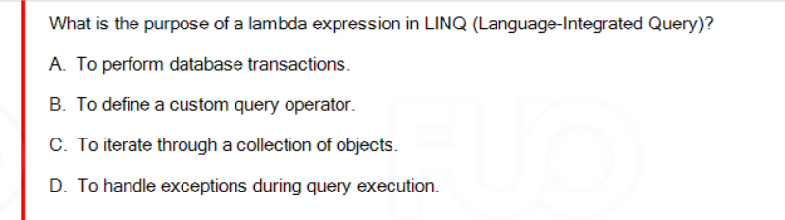

1. To define a custom query operator

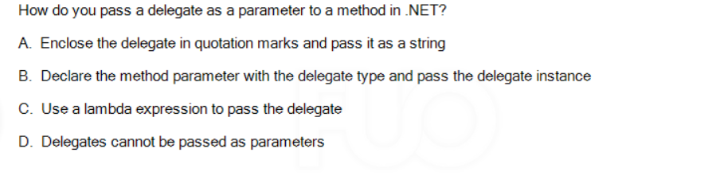

B. Declare the method parameter with the delegate type and pass the delegate instance

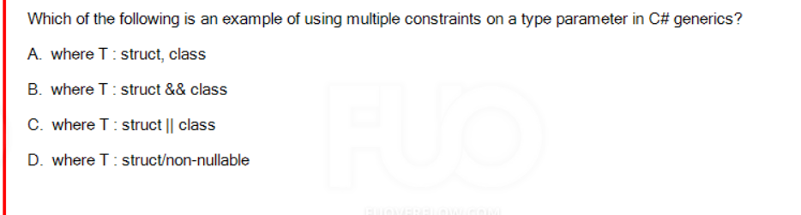

A

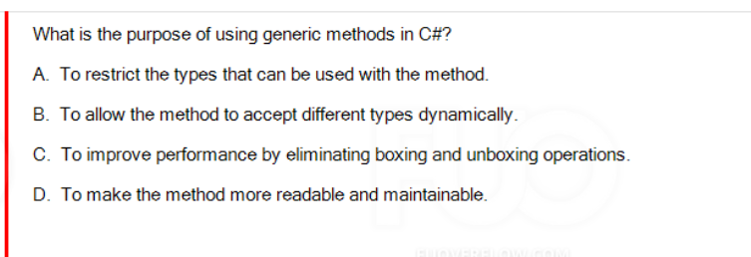

B to allow the method to accept different types dynamically

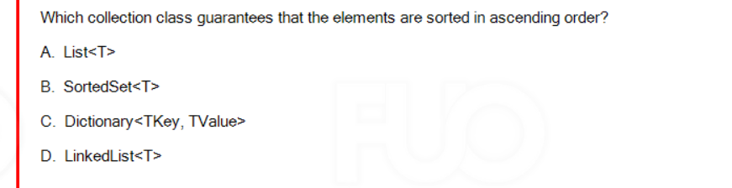

B

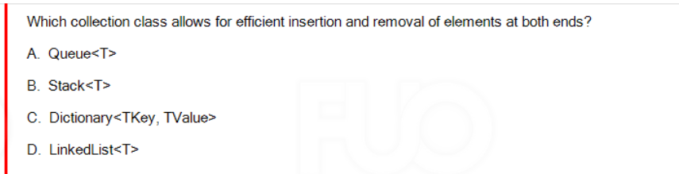

D

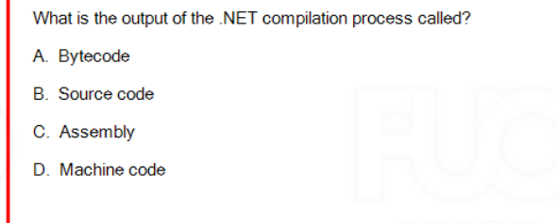

C

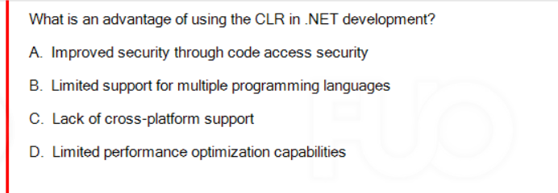

A

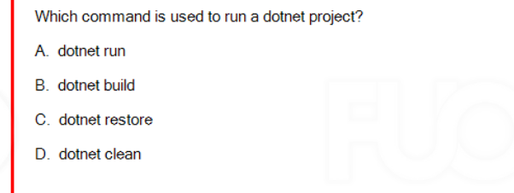

A

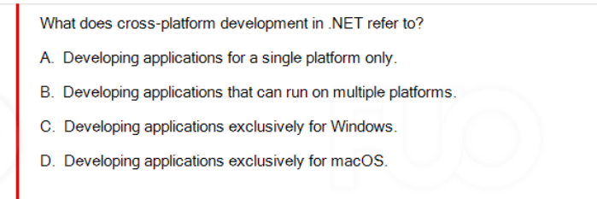

B

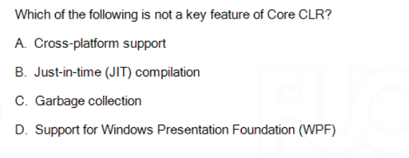

D Supporrt for windows presentation foundation

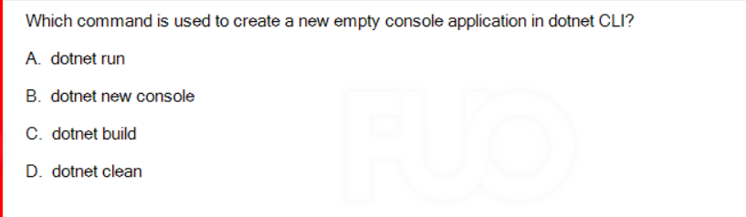

B

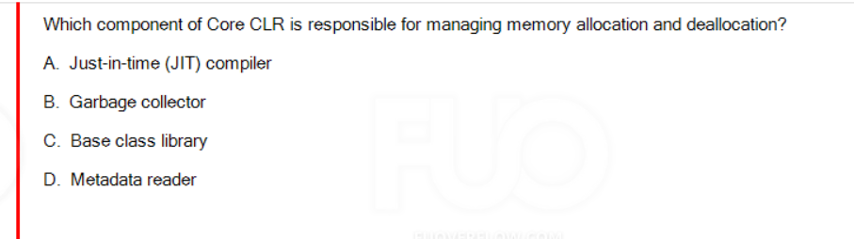

Allocation and deallocation -> Garbage collector